**TITLE**: An Artificial Intelligence Enabled Machine for Human Behavior Detection

**Team Number**: CSM09

**Team Members**: B. Roopesh, T. Laxmi Prasanna, T. Ashwitha Reddy, Y. Siri reddy

**Github Link**: [b-roopesh/Human-Behavior-Detection (github.com)](https://github.com/b-roopesh/Human-Behavior-Detection)

**Project Overflow:**

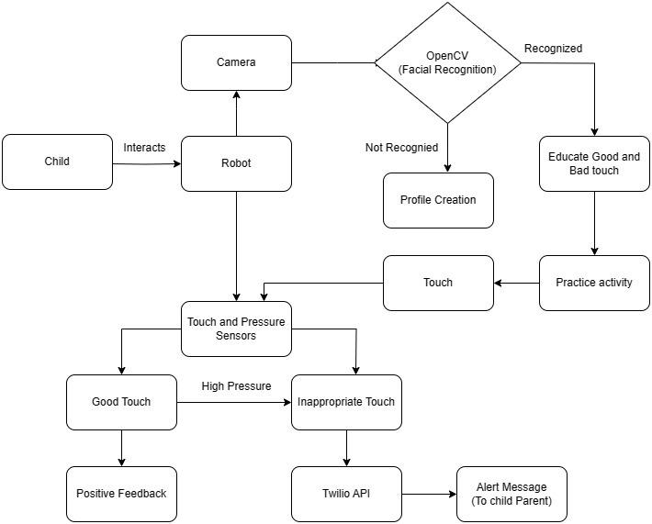

**Work Progress:-**

1. **Completed work**

* Brought all components required for project.
* Done with the basic coding part.
* Installation of open CV library is done in Raspberry Pi

1. **Need to-be Completed**

* Need to assemble and integrate all the components.
* Need a 3D robot model which is hollow from inside to hide all the components of the project.
* Testing of Code need to be done.

**Need Assistance for:**

* Need a 3D model which is hollow from inside to keep the components like Raspberry Pi inside the Model.
* We are looking for a model something similar to : [Buy Negi Pooka Voice Intelligent Robot(Rechargeable Batteries) Online at Low Prices in India - Amazon.in](https://www.amazon.in/Negi-Pooka-Intelligent-Rechargeable-Batteries/dp/B07WSFJT31)
* Models We Found: [pib | Your Printable Intelligent Bot](https://pib.rocks/)